Blue Team Shooting Sports Action Pistol December 9th, 2025
COURSE DESIGNER: Ike Starnes

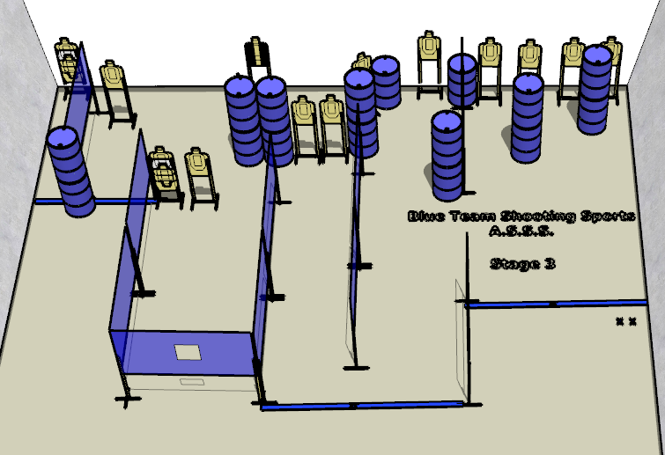

Written Stage Briefing:

Stage 3 – So come and get it - is a 32-round, 160 point, Comstock Course. There are 16 cardboard targets and some noshoots. The best 2 hits per cardboard target will be scored.
Handgun start position Feet on Xs. The handgun is loaded and holstered.
PCC start position Feet on Xs. PCC is loaded with stock touching belt.
All magazines to be used on the stage must be placed on the barrel prior to the start signal.
On the audible start signal, engage all targets from within the shooting area.

